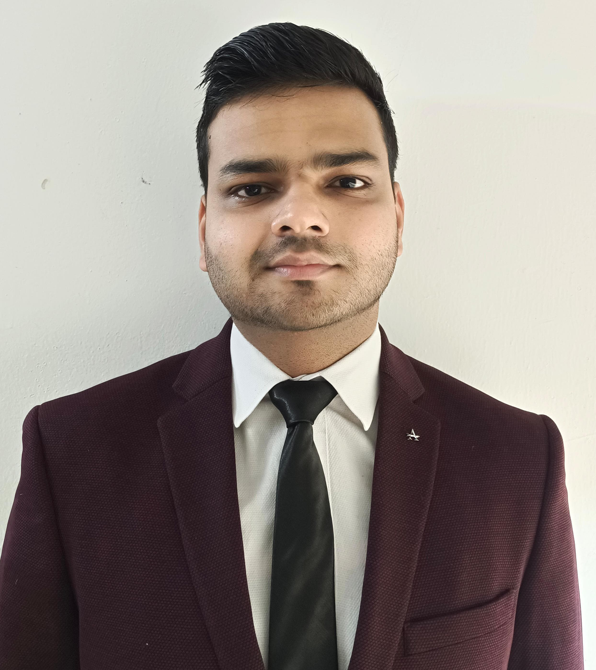

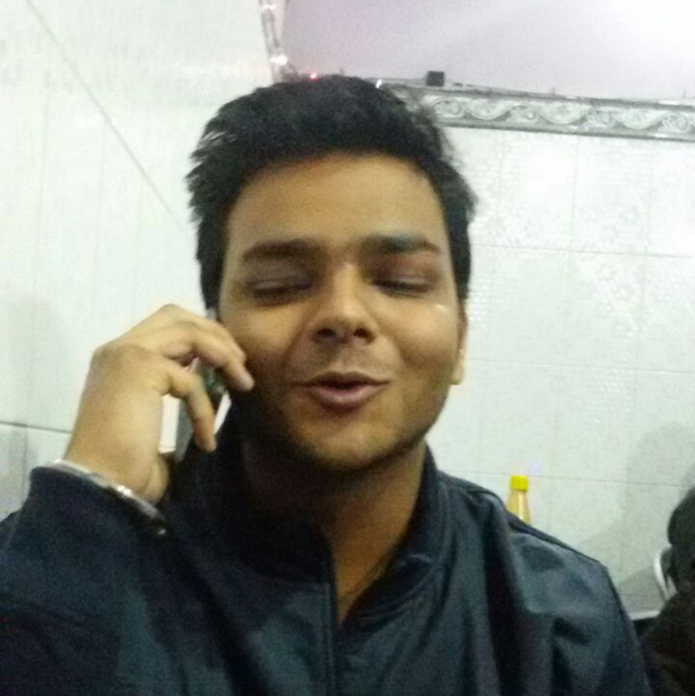

Dhruv Pratap Singh

**Contact no:-**

8279860163

**Email:-**

[dpratap.mba23fin@chitkara.edu.i**n**](mailto:dpratap.mba23fin@chitkara.edu.in)

**LinkedIn:-**

https://[www.linkedin.com/in/dhruv](http://www.linkedin.com/in/dhruv)

-pratap-singh-902507293

Skills

Python

MS Excel

Power BI

Interest

Reading Physiological Novels

Meditation



Dhruv Pratap

Singh

**8279860163**

**Email:**

[**dpratap.mba23fin@chitkara.edu.in**](mailto:dpratap.mba23fin@chitkara.edu.in)

**LinkedIn:**

**https://**[**www.linkedin.com/in/dhruv**](http://www.linkedin.com/in/dhruv)

**-pratap-singh-902507293**

Skills

Python

MS Excel

Power BI

Interest

Reading Physiological Novels

Meditation

Objective

To be a part of an organization that would allow me to apply my knowledge and skills and to be a part of a team that work dynamically toward the organization's growth.

|  |  |
| --- | --- |
| Education |  |
| **MBA in Finance** |  |
| **(Super specialization in Fintech)** |  |
| Chitkara University |  |
| **B.B.A**  Shri Ram Group of College |  |
| **XII**  The Doon Valley Public School |  |
| **X**  The Doon Valley Public School |  |
| Certiﬁcates |  |
| Srijan (National Art Competition) |  |
| Time Value of Money  Global Week (Campus Event) |  |
| Activities |  |

* Participation in Ted Talk Competition
* Participated in a presentation on “India Middle East Europe Economic Corridor in G20 Summit India”
* Presented a play on “Ministry of Skill Development & Entrepreneurship”
* Participated in a presentation on the “Time Value of Money”
* Presented a case study on “Perfetti Van Melle”
* Participated in a presentation on the “Platform Business Model”
* Participated in a presentation on “Starbucks”